The time it takes for me to solve a 7x7x7 Rubik’s cube based on my time on 5x5x5

The general process for solving a big cube is as follows:

first four centers

last two centers

first eight edges

last four edges

3x3

The first four steps reduces the cube into a 3x3x3 cube, and then the cube can be solved like a 3x3x3.

These are the times it takes do each step on a 5x5

for 5x5:

f4c: 35-1:00

l2c: 10

f8e: 1:30-1:50

l4e: 20-1:00

3x3:20-35

for each piece:

f4c: 35/32 = 1.09 , 60/32 = 1.875

for each bar:

l2c:3.33

for each piece

f8e: 90/8/3=3.75, 110 / 8/3 =4.58

l4e:20-60

3x3:20-35

And then, I just used the data above, and multiplied it by the number of pieces on a 7x7, and wrote my simulation based on that.

on a 7x7:

f4c: 104.64 , 180

l2c:16

f8e:150, 183.2

l4e:40-120

3x3:20-35 45-60(This is the actual time it takes for me to finish this step)

There are 4 random variables, so it took a long time to run this… First I ran 100 trials, and the graph looks like this:

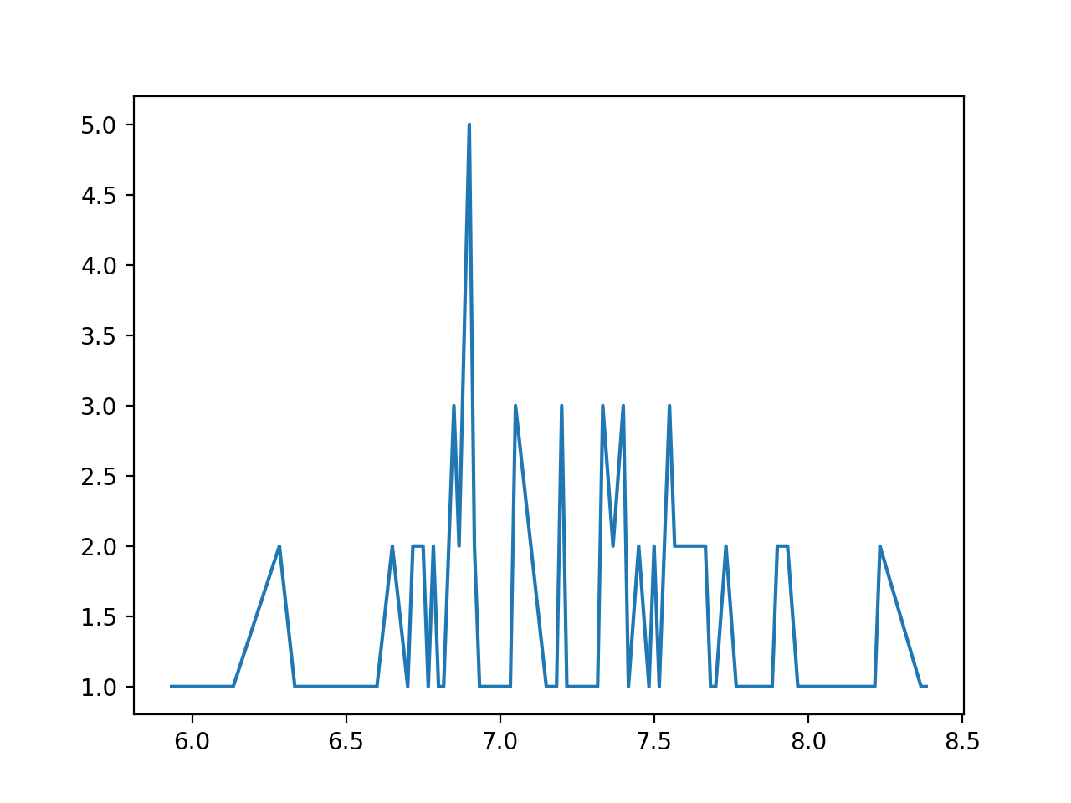

The x axis is the number of minutes it takes me to solve the cube, and the y axis represents how many times a certain times has appeared in the simulation. I thought this is a bit inaccurate, so I ran 10000 trials, which took about 1h30m…

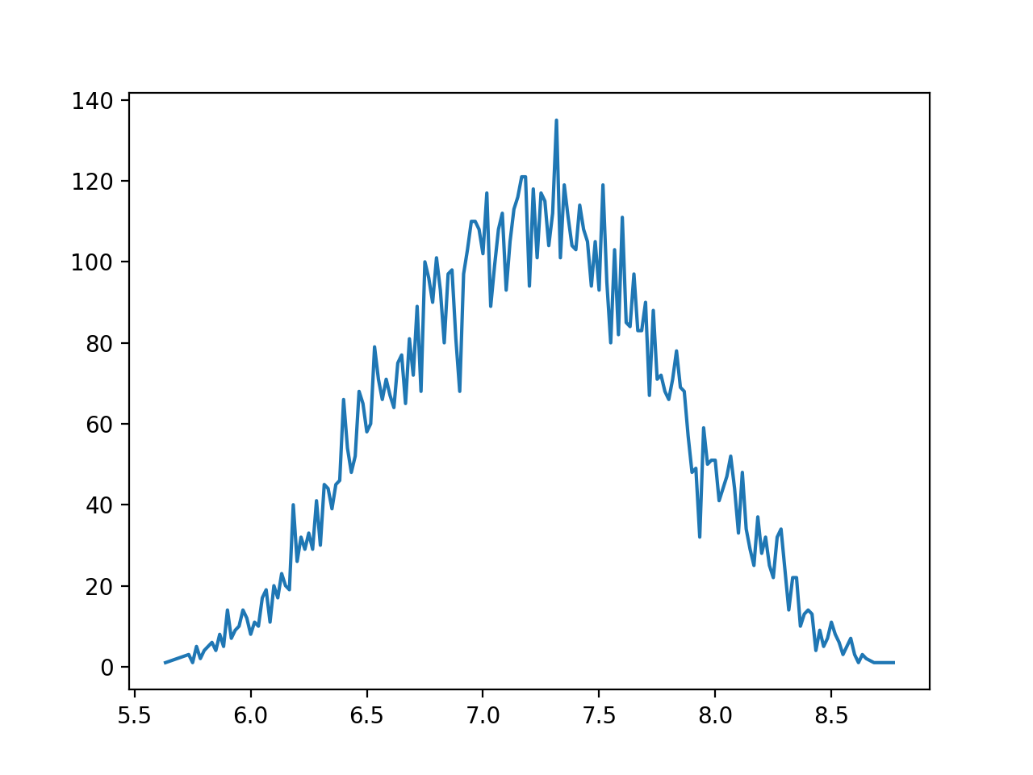

So the simulation shows that it would be most likely for me to get a 7.3 minute on 7x7.